**Woo Commerce Custom codes**

// agr product get krna ha id k sht woocommere product title

<h1><?php $product_id = 511; // Set the product ID

$_product = wc_get_product($product_id); // Get the product

echo $_product->get_name(); // Display the product title ?></h1>

// agr woo-commerce product ki category get krni h

<h3><a href="<?php echo get_term_link($category)?>" ><?php echo $category->name?></a></h3

// agr woo-commere product ki price get krni ho

<?php

global $product;

$product_id = 511; // Set the product ID

$_product = wc_get_product($product_id); // Get the product

echo $_product->get_price(); ?>

// agr ap na woo commerce pr cutom filed bi add krni h ior custom woo-commerce ka bi cheeze mix add krni h tu :

// agr woo-commere product ki price get krni ho

global $product;

$product = wc_get_product( $post_id );

$_product = wc_get_product( $product_id );

echo $product->get_regular_price();

echo $product->get_sale_price();

echo $product->get_price();

businessbloomer.com/woocommerce-easily-get-product-info-title-sku-desc-product-object/

***f.e***

<div class="card-holding"><div class="row">

<?php

if ( $loop->have_posts() ) {

while ( $loop->have_posts() ) : $loop->the_post();

global $product;

$unit = get_field('units',get_the_ID());

$price_per_unit= get_field('price_per_unit',get_the_ID());

$price_sq_ft= get_field('price_sq_ft',get_the_ID());

$price_percentage = get_field('price_percentage',get_the_ID());

$multi_family = get_field('multi_family',get_the_ID());

//echo '<pre>';print_r($multi_family);exit;

$price = get_post_meta( get_the_ID(), '_regular_price', true);

$available = get_field('available',get_the_ID());

$properties_location = get_field('properties_location',get_the_ID());

?>

<div class="card ol-lg-3 col-md-3 col-sm-6">

<im src="<?php echo get_the_post_thumbnail_url(get_the_ID()) ?>" alt="Denim Jeans" style="width:100%">

<div class="card-btnn">

<button class="buttonss button1">Multi family</button>

<button class="buttonss button2">Available</button>

</div>

<h1 class="card-heading" ><?php echo get_the_title()?></h1>

<p class="card-location" ><i class="fa fa-map-marker" style="font-size:18px"></i> <?php echo $properties_location; ?></p>

<div class="card-flex-display" >

<div>

<p><span class="card-span" ><?php echo $unit; ?></span> Units</p>

<p><span class="card-span" ><?php echo $price_per_unit; ?></span> Price Per Unit</p>

<p><span class="card-span" ><?php echo $price_sq_ft; ?></span> Price Sq Ft</p>

</div>

<div>

<h3>Price:</h3>

<p class="card-span" > <?php echo $price; ?></p>

<p class="card-span" > <?php echo $price_percentage; ?>%</p>

</div>

</div>

<button class="button3">View Details</button>

</div>

<?php

endwhile;

} else {

echo __( 'No products found' );

}

?>

</div></div>

<?php

wp_reset_postdata();

return $output;

}

add_shortcode( 'productlist', 'custom_shortcode' );

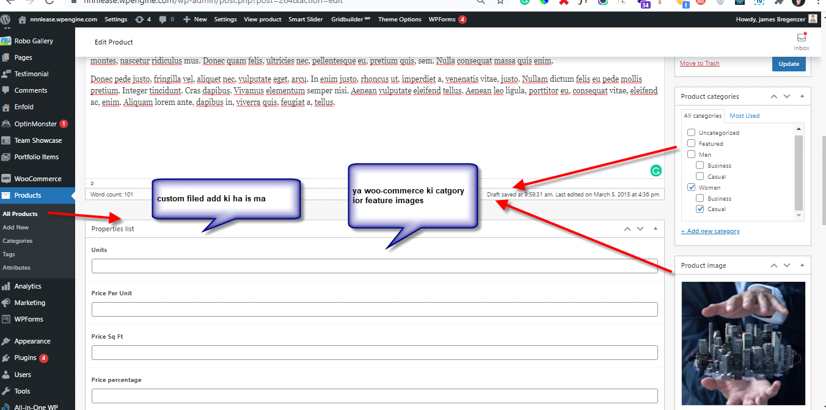

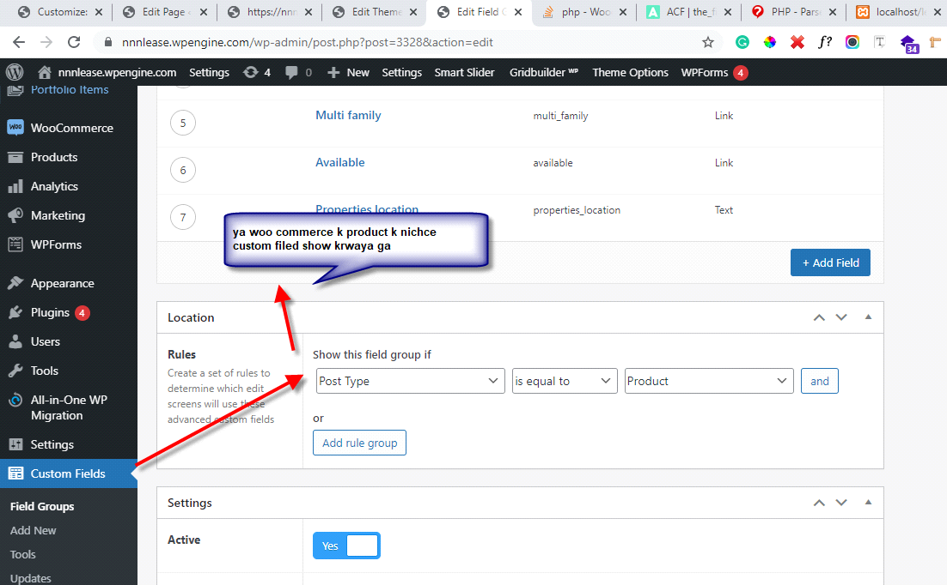

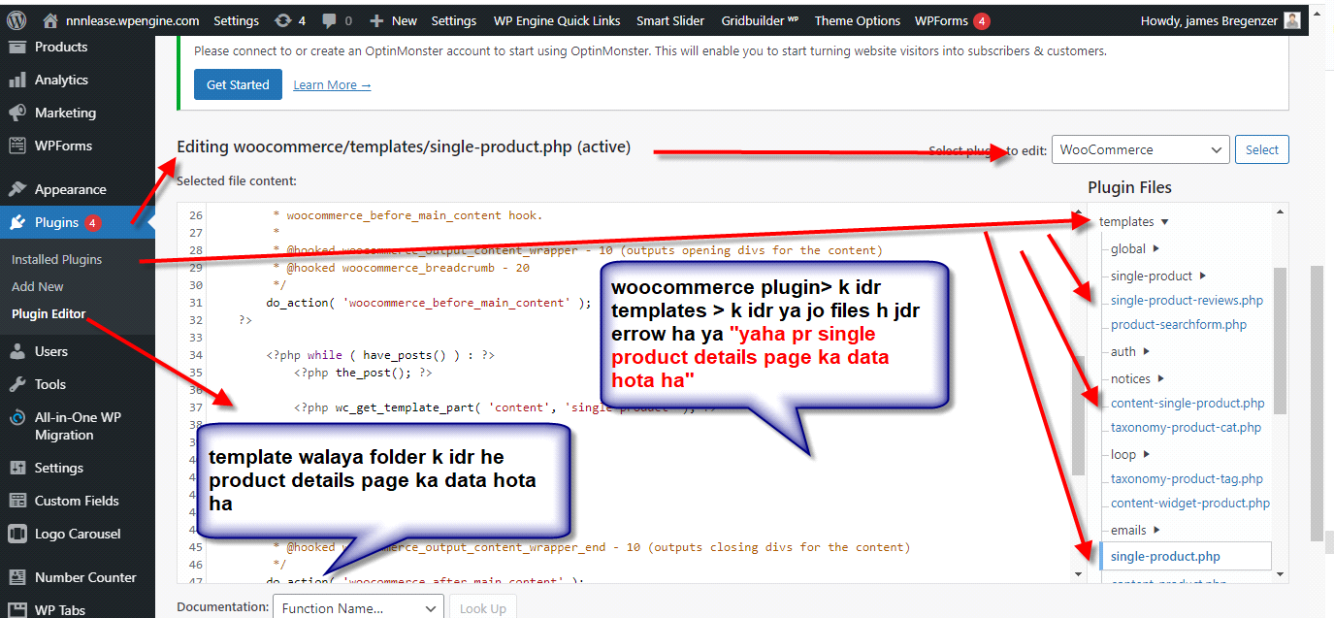

// Woo commerce **breadcrumbs** add in woo-commerce

<?php if (class_exists('WooCommerce') && is_woocommerce()) : ?>

<?php woocommerce_breadcrumb(); ?>

<?php endif; ?>

**// related similar product lanaya k liya**

<?php

global $product; // If not set…

if( ! is_a( $product, 'WC_Product' ) ){

$product = wc_get_product(get_the_id());

}

$args = array(

'posts_per_page' => 4,

'rows' => 1,

'orderby' => 'rand',

'order' => 'desc',

);

$args['related_products'] = array_filter( array_map( 'wc_get_product', wc_get_related_products( $product->get_id(), $args['posts_per_page'], $product->get_upsell_ids() ) ), 'wc_products_array_filter_visible' );

$args['related_products'] = wc_products_array_orderby( $args['related_products'], $args['orderby'], $args['order'] );

// Set global loop values.

wc_set_loop_prop( 'name', 'related' );

wc_set_loop_prop( 'columns', $args['columns'] );

wc_get_template( 'single-product/related.php', $args );

?>

**1: hide empty category in front view this catgeory no product:**

functionwoo_hide_product_categories_widget( $list_args ){

$list_args[ 'hide_empty' ] = 1;

return $list_args;

}

dd_filter( 'woocommerce_product_categories_widget_args', 'woo_hide_product_categories_widget' );

**Woo commerce plugin cutomization with (Pefect web solutions)**